Network Structure of Depression and Anxiety Symptoms in Older Asian Patients With Depressive Disorders: Findings From the REAP-AD3

Abstract
Objective: As the clinical presentation of depressive disorders may be influenced by age, its diagnosis and treatment may be affected by ageism-related bias. Network analysis can reveal the unrecognized symptom patterns from the reductionistic approach. Thus, this study aimed to explore the network structure of depression and anxiety symptoms in older Asian patients with depressive disorders, examining age-related differences in the context of ageism.
Methods: We used the data from the Research on Asian Psychotropic Prescription Patterns for Antidepressants, Phase 3 (REAP-AD3), which included 2,785 psychiatric patients from 11 Asian countries. In addition, depression and anxiety symptoms were assessed using the Patient Health Questionnaire-9 (PHQ-9) and Generalized Anxiety Disorder-7 (GAD-7). Network analyses were conducted to identify symptom interconnections and centrality, among older (>65 years), middle-aged (35–64 years), and young (18–34 years) adult groups, respectively. In addition, the network structures were compared using the Network Comparison Test.
Results: Remarkably, depressed mood was the most central symptom across all age groups. Network comparisons revealed no significant structural differences among the three age groups, despite the several variations in terms of global strength. The network structure of the older group was characterized by the strong interconnections of somatic symptoms (insomnia-energy) and core depressive symptoms (little interest or pleasure-feelings of hopelessness).
Conclusion: This study revealed that the network structures of depression and anxiety symptoms present relatively consistent interconnections across age groups, despite the subtle age-based differences. Specifically, it has been revealed that older adults tend to present anxiety and depression symptoms physical complaints. These findings may challenge ageist stereotypes and advocate for inclusive, age-neutral approaches.

Keywords: age; ageism; anxiety; Asian patients; depression; network analysis

Introduction
Depressive disorders are a significant public mental health issue worldwide.¹⁻³ Since many subtypes of depressive disorders have been defined because of their heterogeneous nature,⁴ age may be regarded as one of the most influential factors in their clinical presentation and classification. However, inconsistencies in age-related features have been reported in previous several studies.⁵ Notably, the severity of depression tends to be lower in older individuals than in younger individuals. Regarding specific symptoms, younger patients are characterized by severe suicidal ideation, guilt, and irritability, whereas older patients predominantly exhibit somatic symptoms, illness anxiety, and insomnia, particularly early morning awakening.⁶⁻⁹ The pervasive influence of ageism necessitates a critical evaluation of its impact on the perception and treatment of depression and aging. Ageism, affecting both older and younger populations, denotes the stereotypes, prejudice, and discrimination based on age. In term of depressive disorders, older adults are often perceived as frail or dependent, contributing to their marginalization in mental health care and research. Conversely, younger individuals with depressive disorders are frequently regarded as being impulsive or irresponsible. Such biases may exacerbate care inequities and reinforce internalized societal stereotypes, manifesting as self-perceived ageism, further influencing their mental health outcomes.¹⁰⁻¹²
Furthermore, a recent neuroimaging study on age-related changes in the brain networks support the complexity of depression manifestations across the lifespan. In older adults, structural connectivity exhibits compensatory reorganization in response to cognitive function decline, using mechanisms of the redundancy in large-scale brain networks. It has been suggested that these networks can provide the alternative pathways for information processing. In addition, the networks may be protected by the factors that mitigate age-related changes, particularly in areas associated with cognitive control and default mode activity.¹³ Network analysis can reveal unrecognized symptom patterns from conventional reductionistic approaches, because it is based on bottom-up approach but not top-down approach. These compensatory processes align with the age-associated clinical features of depressive disorders. In addition, since anxiety symptoms are closely associated with depression symptoms, anxiety symptoms can influence on the network structure of depression symptoms in patients with depressive disorders.¹⁴ Thus, this study aimed to compare the network structures of depression and anxiety symptoms among older (> 65 years), middle-aged (35-64 years), and young adult (18-34 years) Asian patients with depressive disorders, using data from the Research on Asian Psychotropic Prescription Patterns for Antidepressants, Phase 3 (REAP-AD3).^{15,16} Specifically, this study aimed to characterize the network structure of older Asian patients with depressive disorders in the context of ageism.

Methods
Study participants
The REAP-AD3 study, conducted from August 2023 to February 2024 across 11 Asian countries, including China, India, Indonesia, Iran, Japan, Korea, Malaysia, Pakistan, Singapore, Taiwan, and Thailand, is a large-scale research project that has included 4,587 psychiatric patients receiving antidepressant treatment. In the REAP-AD3 study, participants were selected based on their antidepressant use. Ethical reviews of the study protocol and informed consent forms were conducted and approved by the institutional review boards of all study centers, including Hanyang University Guri Hospital in Guri, Republic of Korea (receipt number: 2023-05-021-006). All participants provided written informed consent for their data to be used for research purposes. Coordinated by the REAP consortium, data collection was securely managed via a web-based platform hosted by Taipei City Hospital.
The inclusion criteria were as follows: (i) a diagnosis of depressive disorders, including depressive episode (F32), recurrent depressive disorder (F33), and persistent depressive disorder (F34), according to the International Classification of Diseases, tenth edition (ICD-10),¹⁷ as determined by clinical psychiatrists; (ii) the use of at least one antidepressant classified under the Anatomical Therapeutic Chemical classification system;¹⁸ and (iii) age of at least 18 years. The exclusion criteria were as follows: (i) severe medical or neurological conditions, (ii) inability to provide informed consent, and (iii) age less than 10 years. Finally, this study included a sample of 2,785 Asian patients with depressive disorders, comprising 264 older, 1,277 middle-aged, and 1,244 young adults.

Variable and data collection
Data were collected through personal interviews and self-administered questionnaires by clinical coordinators at the research centers. The variables considered included age, sex, country, treatment setting (outpatient or inpatient), psychiatric diagnosis, use of psychotropic medications (antidepressants, antipsychotics, mood stabilizers, anxiolytics, or hypnotics), and other clinical factors. Depression and anxiety symptoms were evaluated using the Patient Health Questionnaire-9 (PHQ-9)¹⁹ and Generalized Anxiety Disorder-7 (GAD-7),²⁰ respectively. Higher scores on the PHQ-9 and GAD-7 indicate greater severity of depression and anxiety symptoms. Both the PHQ-9 and GAD-7 have been formally translated into various Asian languages, with their reliability and validity considered to be at favorable levels.²¹⁻²⁵.
The abbreviations for the PHQ-9 items are as follows: APE, poor appetite or overeating; CNC, trouble concentrating on things such as reading the newspaper or watching television; DEP, feeling down, depressed, or hopeless; ENG, feeling tired or having little energy; HUR, thoughts that you would be better off dead or of hurting yourself in some way; INS, trouble falling or staying asleep, or sleeping too much; PLE, little interest or pleasure in doing things; SEL, feeling bad about yourself, or feeling that you are a failure or have let yourself or your family down; SLW, moving or speaking so slowly that others could have noticed, or the opposite—being so fidgety or restless that you have been moving around much more than usual. The abbreviations for the GAD-7 items are as follows: ANX, feeling nervous, anxious, or on edge; AWF, feeling afraid, as if something awful might happen; DFF, worrying too much about different things; IRR, becoming easily annoyed or irritable; RLX, trouble relaxing; RTL, being so restless that it is hard to sit still; and WOR, not being able to stop or control worrying.

Statistical analysis
To examine the characteristics of the network structure of depression and anxiety symptoms in older Asian patients with depressive disorders, this study used the R package qgraph.²⁶ Network structures including nodes (depression and anxiety symptoms) and edges (associations between the symptoms) were constructed, based on the PHQ-9 and GAD-7 item responses. The least absolute shrinkage and selection operator minimized false-positive edges, with very small edges set to zero.²⁷ Edges represented partial correlation coefficients, which reflect symptom relationships while controlling for others. The extended Bayesian information criterion optimized the shrinkage parameter,²⁸ and the Fruchterman–Reingold algorithm visualized the network structures by clustering related nodes.²⁹ The PHQ-9 and GAD-7 items were treated as ordered categorical variables, ranging from 0 to 4, with network estimation based on polychoric correlations. Community structures were assessed using the spin-glass algorithm from the R package igraph, which detects clusters based on edge strength and density.³⁰ Centrality metrics were calculated, focusing on node strength (the sum of all edge weights), closeness (symptom integration), and betweenness (nodes acting as bridges). Stability was evaluated using bootstrapping, with correlation stability (CS) coefficients > 0.250 (preferably > 0.500), indicating robust results.³¹
To compare the network structures of depression and anxiety symptoms across different age groups, this study employed the network comparison test with 100 iterations via the NetworkComparisonTest (NCT) package.³² Structural and global strength invariance was tested, and Spearman's correlation coefficient assessed differences in node centrality and edge weights, with p < 0.05 considered significant (two-tailed). All statistical analyses were conducted using R 4.3.3 (R Foundation for Statistical Computing, Vienna, Austria).

Results
Sample description
As shown in Table 1, 9.5% (n =264) were classified as older group of 2,785 study participants. The average age of older group was 68.4 (standard deviation [SD] =16.4). The older group was characterized by high proportion of outpatient (75.6%) and female (65.6%). Most of the older group was East Asian (37.9%) or Southeast Asian (35.9%). In addition, the group was prescribed with adjunctive use of antipsychotic (32.0%) and anxiolytic (32.0%). Tables 2 and 3, the response frequency distributions showed that older group present relative lower scores on the individual PHQ-9 and GAD-7 items compared with middle-aged and young adult groups.

Network structure of depression and anxiety symptoms in older patients with depressive disorders
As shown in Figure 1(a), 69 (57.5%) out of the 120 possible edges were identified within the estimated network structure of depression and anxiety symptoms in the older group. All identified edges were estimated to be greater than 0. In terms of edge statistics, PLE-DEP (weight = 0.487) had the most significant interconnection, followed by WOR-RLX (0.442), RLX-RTL (0.356), CNC-SLW (0.276), APE-SEL (0.266), RTL-IRR (0.261), and INS-ENG (0.251). The edges were assessed as favorable, with a CS-coefficient of 0.441. In terms of node statistics, as illustrated in Supplementary Figure 1(a), DEP was the most central node within the network, followed by RLX, WOR, ANX, RTL, and SEL, whereas INS was the least central. Node strength centrality demonstrated a meaningful level, with a CS-coefficient of 0.281. A community detection method indicated that depression and anxiety symptoms were organized into two meaningful clusters. Cluster A consisted of PLE-DEP-INS-ENG-APE-SEL-CNE-SLW (i.e., depression symptoms interconnection), and cluster B included HUR-ANX-WOR-DFF-RLX-RTL-IRR-AWF (i.e., anxiety symptoms interconnection). HUR was the only PHQ-9 item that constituted cluster B.

Network structures of depression and anxiety symptoms in middle-aged and young adult patients with depressive disorders
As shown in Figure 1(b), 81 (67.5%) out of the 120 potential edges were observed within the estimated network structure of depression and anxiety symptoms in the middle-aged group. Most of the present edges were estimated to be greater than 0, with the exceptions of SEL-WOR (-0.010), INS-AWF (-0.048), ENG-HUR (-0.055), and HUR-ANX (-0.061). In terms of edge statistics, PLE-DEP (weight = 0.367) represented the most significant interconnection, followed by ANX-WOR (0.272), SLW-HUR (0.257), and DEP-HUR (0.250). The edge was estimated to be at the highest level, with a CS-coefficient of 0.750. Regarding node statistics, as illustrated in Supplementary Figure 1(b), DEP was the most centrally located node within the network, followed by ANX, WOR, RLX, HUR, and RTL, whereas APE was the least central. Node strength centrality exhibited a favorable level, with a CS-coefficient of 0.517. A community detection method indicated that the depression and anxiety symptoms were organized into two meaningful clusters. Cluster A included PLE-DEP-INS-ENG-APE-SEL-CNE-SLW-HUR (representing the interconnection of depression symptoms), whereas cluster B encompassed ANX-WOR-DFF-RLX-RTL-IRR-AWF (reflecting the interconnection of anxiety symptoms).
As shown in Figure 1(c), 79 (65.8%) out of the 120 possible edges were identified within the estimated network structure of depression and anxiety symptoms in the young adult group. Most of the identified edges were estimated to be greater than 0, with the exceptions of PEL-RTL (-0.010), ENG-SLW (-0.015), and DEP-RTL (-0.062). Regarding edge statistics, PLE-DEP (weight = 0.423) represented the most significant interconnection, followed by SEL-HUR (0.329), WOR-DFF (0.322), ANX-WOR (0.283), and INS-APE (0.258). The edge with the highest estimate was characterized by a CS-coefficient of 0.750. In terms of node statistics, as illustrated in Supplementary Figure 1(c), DEP was the most centrally located node within the network, followed by WOR, RTL, DFF, RLX, and ANX, whereas AWF was the least centrally located. Node strength centrality exhibited a favorable level, with a CS-coefficient of 0.516. A community detection method indicated that the depression and anxiety symptoms were organized into two meaningful clusters. Cluster A included PLE-DEP-INS-ENG-APE-SEL-CNE-SLW-HUR (representing interconnections among depression symptoms), whereas cluster B consisted of ANX-WOR-DFF-RLX-RTL-IRR-AWF (representing interconnections among anxiety symptoms).

Comparing the network structures between older, middle-aged, & young adult patients with depressive disorders
As shown in Table 4, the comparison of network structures between older (Network 1) and middle-aged (Network 2) patients with depressive disorders revealed no significant differences in network structure invariance, network structure invariance with equal sample sizes, global strength invariance, and global strength invariance with equal sample sizes. Spearman correlations of node strength centrality and edges indicated a strong correlation (0.83) and a very strong correlation (0.94), respectively. Additionally, the comparison of network structures between older (Network 1) and young adult (Network 3) patients with depressive disorders demonstrated no significant differences in terms of network structure invariance, network structure invariance with equal sample sizes, and global strength invariance with equal sample sizes. However, a significant difference was found in the global strength invariance between the two network structures (p-value = 0.01). Spearman correlations of node strength centrality and edges indicated a strong correlation (0.74) and a very strong correlation (0.92), respectively.
Lastly, as shown in Figure 2(a), the network structure of anxiety and depression symptoms was estimated using a combined of all age groups to visualize the similarities and differences in the edge connections across groups. Network analysis of the GAD-7 and PHQ-9 items revealed that 83 (69.1%) of the 120 possible edges had an estimated weigh greater than zero. Several strong interconnections were identified in the network, including the following item pairs: PLE-DEP (0.429), WOR-DFF (0.282), ANX-WOR (0.273), SEL-HUR (0.250), INS-ENG (0.229), RLX-RTL (0.227), and WOR-RLX (0.222). Edge statistics indicated a high level of interpretability with a CS coefficient of 0.750. As shown in Figure 2(b), the node strength centrality analysis showed that DEP was the most central symptoms, followed by WOR, ANX, RLX, HUR, and RTL. In contrast, RTL was the least interconnected symptom in the network, followed by APE, AWF, IRR, and CNC. Node statistics indicated a high level of interpretability with a CS coefficient of 0.750.

Discussion

This study revealed that there were no significant differences in the network structure of anxiety and depression symptoms across the age groups, although the symptom severities vary according to age groups in patients with depressive disorders. Although the symptom network structures have been presented as a consistent manner, subtle differences have been observed, particularly in the interconnection and expression of symptoms. Lamers et al.³³ have demonstrated that the structure of depression in adolescents are similar to the structure in adults, using the factor analysis. The findings may support to adopt age-neutral diagnostic frameworks to accommodate shared and age-specific symptom interconnections while minimizing the impact of ageist biases. An age-neutral diagnostic framework can be an approach to diagnosing mental disorder to minimize the influence of age-related biases. These frameworks focus on identifying and evaluating symptoms based on their intrinsic characteristics, rather than relying on assumptions or stereotypes about how symptoms may manifest in different age groups. Advancing the equitable and inclusive integrative care for depressive disorder may be needed by acknowledging consistent symptomatic patterns.³⁴⁻³⁶ In older adults, ageism may lead to the misinterpretation of depressive disorders as a natural part of aging and depressive symptoms can be manifested as physical complaints.³⁷ In addition, the findings can be discussed as follows: First, they may challenge ageist assumptions that age may mainly influence on clinical presentations and reinforce biases in treatment priorities. The subtle differences observed in global strength and symptom connectivity indicate that depression and anxiety manifest in consistently interconnected ways throughout the lifespan. In our findings, the strong centrality of depressive mood and its connections to worry and restlessness across age groups highlight that effective treatment approaches may target shared symptom nodes regardless of the patient's age. Second, against the ageist tendencies to over-pathologize or under-pathologize the certain age groups, they may advocate for a more inclusive perspective in the mental health care on depressive disorders. Ageism often manifests as exaggerated distinctions between younger and older adults, and it finally leads to the marginalization of older populations in clinical trials and the allocation of resources.^{10-12,38} By demonstrating the structural similarity of depression and anxiety symptom networks across age groups, this study may prompt a paradigm shift toward age-neutral diagnostic and therapeutic strategies. Thus, improvements in diagnostic approaches for older adults with depressive disorders may be needed against the ageism-related biases. Third, while symptom networks remain similar across age groups, the anxiety and depression may be differently caused according to individual age groups with depressive disorders. In older adults, the strong interconnection between insomnia and fatigue may be causatively associated with physical illness and social isolation.³⁹ Contrastingly, in middle-aged adults, the strong interconnection between depressive mood and excessive worry may be caused by workplace stress and family caregiving burden⁴⁰ and, in young adults, the strong interconnection between anxiety and self-criticism may be caused by the economic insecurity, social comparison, and interpersonal stress.⁴¹ Thus, the age-related individualized approaches to prevent age-related biases may be needed in treating the depressive disorders.

Network structure of depression and anxiety symptoms in older patients have presented the relatively strong interconnection of somatic symptoms (i.e., insomnia-energy), core depressive symptoms (e.g., loss of interest or pleasure-depressive mood) and anxiety-related symptoms (e.g., worry-restlessness). These findings can contribute to the reconsideration of ageist stereotypes that often marginalize older adults as frail and cognitively declining. The identification of depressive mood as the most central symptom highlights its pivotal role in the symptom network of older patients, emphasizing its potential as a primary therapeutic target. In addition, the findings can be discussed as follows: Compared to depression in young adulthood, late-life depression may be categorized based on the differences in the structural neuroimaging, distinct clinical features, genetic patterns, and susceptibility to future neurodegenerative diseases.⁴² In addition, repeated depressive episodes may be associated with the acceleration to biological aging.⁴³ This perspective suggests that the core symptomatic phenomenon of depression resides in feelings of hopelessness, while age-related variations (i.e., pronounced cognitive decline, prominent physical symptoms) in older adults, may represent unique characteristics of depressive disorders. In addition, young adult group has presented subtle different finding including the relatively strong interconnection between self-criticism and self-hurting. It can be speculated as follows: The unstable job security may be usually presented by younger individuals compared to older adults.⁴⁴ The economic insecurity and social isolation associated with the unstable condition may contributed to a heightened risk of suicide in young adult group.⁴⁵ Moreover, it is speculated that the biological interaction of aging and accelerating aging associated with depressive disorders be differently presented. In young adults, energy depletion can contribute to functional decline, associated with social vulnerability to exacerbate job security and worsen economic conditions. Also, their feelings of deprivation and isolation can be increased as compared to their non-depressed peers. Thus, these biological and social factor may result in the subtle variations in symptom networks across age groups.⁴³
Our study has several limitations as follows: First, the cross-sectional design limits our ability to infer causality or temporal changes in symptom networks. Longitudinal studies are required to examine how symptom interconnections evolve. Second, reliance on self-report measures may introduce response bias, particularly among older adults who may underreport emotional symptoms because of cultural or generational attitudes toward mental health. Third, variations in the sample size across age groups and countries may influence on the generalizability of our findings. Further research is necessary to investigate whether interventions targeting shared central symptoms, including depressive mood and excessive worry, can mitigate the effects of ageist biases in mental health care.⁴⁶ Fourth, PHQ-9 and GAD-7 may lack the sensitivity needed to capture age-specific psychiatric manifestations and the potential influence of cultural and generational factors on symptom reporting. Fifth, depression and anxiety symptom networks may vary across cultural and racial contexts, influencing symptom clustering and connectivity patterns. To enhance the generalizability of these findings, further study may be needed to examine whether similar network structures emerge in Western older adults or not. Comparing cross-cultural symptom networks could clarify whether these interconnections reflect universal aging-related mechanisms or culture-specific expressions of depression, informing more targeted diagnostic and therapeutic approaches. Sixth, since there is a potential overlap between anxiety/depression symptoms and other certain psychiatric conditions, it may have influenced on the findings. Lastly, the influence of antidepressants on the symptom expression should be considered. The anxiety and depression symptoms can be alleviated by antidepressants including selective serotonin reuptake inhibitors (SSRIs).⁴⁷
Despite these limitations, using network analysis, our study has a virtue to challenge the stereotypes of depressives disorders counting ageism. Our study highlights the relatively consistent interconnection of depression and anxiety symptoms across different age groups, although the symptom severities vary according to age groups. By identifying potentially central symptoms and advocating for inclusive and equitable mental health care, this study may contribute to the growing movement to advance age-neutral approaches in the diagnosis and treatment of depressive disorders.

Availability of Data and Material
The datasets generated or analyzed during the study are not publicly available because of institutional ownership but are available from the corresponding author upon reasonable request.

Conflict of Interest
Seon-Cheol Park, a contributing editor of the Psychiatry Investigation, was not involved in the editorial evaluation or decision to publish this article.

Author Contributions
Conceptualization: Seon-Cheol Park, Afzal Javed, Kang Sim, Shih-Ku Lin, Takahiro A. Kato, Naotaka Shinfuku, Norman Sartorius
Data curation: Seon-Cheol Park, Seungwon Cho, Tian-Mei Si, Roy Abraham Kallivayalil, Andi J Tanra, Amir Hossein Jalali Nadoushan, Kok Yoon Chee, Afzal Javed, Kang Sim, Pornjira Pariwatcharakul, Shih-Ku Lin, Takahiro A. Kato
Formal analysis: Seon-Cheol Park, Kiwon Kim, Jeongsoo Park, Sun Choi, Seonhwa Lee, Eunkyung Kim
Investigation: Seon-Cheol Park, Seungwon Cho
Resources: Seon-Cheol Park, Tian-Mei Si, Roy Abraham Kallivayalil, Andi J Tanra, Amir Hossein Jalali Nadoushan, Kok Yoon Chee, Afzal Javed, Kang Sim, Pornjira Pariwatcharakul, Shih-Ku Lin, Takahiro A. Kato
Supervision: Afzal Javed, Kang Sim, Shih-Ku Lin, Takahiro A. Kato, Naotaka Shinfuku, Norman Sartorius
Validation: Seon-Cheol Park
Visualization: Seon-Cheol Park
Writing-original draft: Seon-Cheol Park
Writing-review & editing: Seon-Cheol Park, Kiwon Kim, Jeongsoo Park, Sun Choi, Seonhwa Lee, Eunkyung Kim

ORCID iDs
Seon-Cheol Park: https://orcid.org/0000-0003-3691-4624
Kiwon Kim: https://orcid.org/0000-0001-7594-0142
Jeongsoo Park: https://orcid.org/0000-0001-6444-491X
Sun Choi: https://orcid.org/0009-0005-7807-416X
Seonhwa Lee: https://orcid.org/0000-0001-6803-9815
Seungwon Cho: https://orcid.org/0000-0001-7852-5876
Eunkyung Kim: https://orcid.org/0000-0002-7881-2995
Tian-Mei Si: https://orcid.org/0000-0001-9823-2720
Roy Abraham Kallivayalil: https://orcid.org/0000-0002-1991-3796
Andi J Tanra: https://orcid.org/0000-0002-3962-4190
Amir Hossein Jalali Nadoushan: https://orcid.org/0000-0002-0819-3981
Kok Yoon Chee: https://orcid.org/0000-0002-5755-9572
Afzal Javed: https://orcid.org/0000-0003-2518-0688
Kang Sim: https://orcid.org/0000-0003-3209-9626
Pornjira Pariwatcharakul: https://orcid.org/0000-0003-0228-3043
Shih-Ku Lin: https://orcid.org/0000-0002-5123-0389
Takahiro A. Kato: https://orcid.org/0000-0001-5169-2930
Naotaka Shinfuku: https://orcid.org/0000-0002-7390-9077
Norman Sartorius: https://orcid.org/0000-0001-8708-6289

Funding Statement
This research has been supported by the AMOREPACIFIC Foundation.

Acknowledgments
We would like to thank Dr. Jinseob Kim for his valuable help with the network analysis.

References
- Jo S, Han KD, Yoo J, Shin DW, Kim H, Jeon HJ. Abdominal obesity increases the risk for depression by sex: a nationwide cohort study in South Korea. Psychiatry Investig 2024;21(12):1398-1406.
- Jung E, Ryu HH, Ryu SJ. Effect of the interaction between depression and sleep disorders on stroke occurrence: a 17-year prospective cohort study in Korea. Psychiatry Investig 2024;21(12):1391-1397.
- Moon JY, Kim SY, Yang S, Yoon S. Validity and reliability of the Korean version of Gotland Male Depression Scale. Psychiatry Investig 2025;22(1):102-109.
- Lichtenberg P, Belmaker RH. Subtyping major depressive disorder. Psychother Psychosom. 2010;79(3):131—5.
- Husain MM, Rush AJ, Sackeim HA, Wisniewski SR, McClintock SM, Craven N, et al. Age-related characteristics of depression: A preliminary STAR*D report. Am J Geriatr Psychiatry. 2005;13(10):852–60.
- Gatz M, Hurwicz ML. Are old people more depressed? Cross-sectional data on Center for Epidemiological Studies Depression Scale factors. Psychol Aging. 1990;5(2):284–290.
- Goldberg JH, Breckenridge JN, Sheikh JI. Age differences in symptoms of depression and anxiety: Examining behavioral medicine outpatients. J Behav Med. 2003;26(2):119–132.
- Maes M. Effects of age and gender on the classification and phenomenology of unipolar depression. Acta Neuropsychiatr. 2002;14(1):29–35.
- Wilkowska-Chmielewska J, Szelenberger W, Wojnar M. Age-dependent symptomatology of depression in hospitalized patients and its implications for DSM-5. J Affect Disord. 2013;150(1):142–145.
- World Health Organization. Global action plan on the public health response to dementia 2017–2025. Geneva: World Health Organization; 2017.
- World Health Organization. Global campaign to combat ageism: Toolkit. Geneva: World Health Organization; 2021.
- World Health Organization. Global report on ageism. Geneva: World Health Organization; 2021.
- Stanford W, Mucha PJ, Dayan E. Age-related differences in network controllability are mitigated by redundancy in large-scale brain networks. Commun Biol. 2024;7:701.
- Park SC, Kim D. The centrality of depressive and anxiety symptoms in major depressive disorder determined using a network analysis. J Affect Disord. 2020;271:19–26.
- Park SC, Shinfuku N, Maramis MM, Lee MS, Park YC. Adjunctive antipsychotic prescriptions for outpatients with depressive disorders in Asia: The Research on Asian Psychotropic Prescription Patterns for Antidepressants (REAP-AD) study. Am J Psychiatry. 2015;172(7):684–686.
- Park SC, Jang EY, Xiang YT, Kanba S, Kato TA, Chong MY, et al. Network analysis of the depressive symptom profiles in Asian patients with depressive disorders: Findings from the Research on Asian Psychotropic Prescription Patterns for Antidepressants (REAP-AD). Psychiatry Clin Neurosci 2020;74(4):344-353.
- World Health Organization. The ICD-10 classification of mental and behavioural disorders: clinical descriptions and diagnostic guidelines. Geneva: World Health Organization; 1992.
- World Health Organization. Anatomical therapeutic chemical (ATC) classification system. Geneva: World Health Organization; 2023.
- Spitzer RL, Kroenke K, Williams JB. Validation and utility of a self-report version of PRIME-MD: The PHQ primary care study. JAMA. 1999;282(18):1737–1744.
- Sapra A, Bhandari P, Sharma S, Chanpura T, Lopp L. Using Generalized Anxiety Disorder-2 (GAD-2) and GAD-7 in a primary care setting. Cureus. 2020;12(5):e8224.
- He X, Li C, Qian J, Cui H, Wu W. Reliability and validity of a generalized anxiety disorder scale in general hospital outpatients. Shanghai Arch Psychiatry. 2010;22(4):200–203.
- Lee SH, Shin C, Kim H, Jeon SW, Yoon HK, Ko YH, et al. Validation of the Korean version of the Generalized Anxiety Disorder 7 self-rating scale. Asia Pac Psychiatry. 2022;14(1):e12421.
- Muramatsu K, Miyaoka H, Kamijima K, Muramatsu Y, Tanaka Y, Hosaka M, et al. Performance of the Japanese version of the Patient Health Questionnaire-9 (J-PHQ-9) for depression in primary care. Gen Hosp Psychiatry. 2018;52:64–69.
- Park SJ, Choi HR, Choi JH, Kim K, Hong JP. Reliability and validity of the Korean Version of the Patient Health Questionnaire-9 (PHQ-9). Anxiety Mood. 2010;6(2):119–124.
- Wang W, Bian Q, Zhao Y, Li X, Wang W, Du J, et al. Reliability and validity of the Chinese version of the Patient Health Questionnaire (PHQ-9) in the general population. Gen Hosp Psychiatry. 2014;36(5):539–544.
- Epskamp S, Cramer AOJ, Waldorp LJ, Schmittmann VD, Borsboom D. qgraph: Network visualizations of relationships in psychometric data. J Stat Softw. 2012;48(4):1–18.
- Tibshirani R. Regression shrinkage and selection via the Lasso. J R Stat Soc Ser B Stat Methodol. 1996;58(1):267–288.
- Chen J, Chen Z. Extended Bayesian information criteria for model selection with large model spaces. Biometrika. 2008;95(3):759–771.
- Csárdi G, Nepusz T. The igraph software package for complex network research. InterJournal. 2006;Complex Systems:1695.
- Opsahl T, Agneessens F, Skvoretz J. Node centrality in weighted networks: Generalizing degree and shortest paths. Soc Networks. 2010;32(3):245–251.
- Cohen J. Statistical power analysis for the behavioral sciences. 2nd ed. New York: Routledge; 2013.
- van Borkulo CD, van Bork R, Boschloo L, Kossakowski JJ, Tio P, Schoevers RA, et al. Comparing network structures on three aspects: A permutation test. Psychol Methods. 2023;28(6):1273–1285.
- Lamers F, Burstein M, He J, Avenevoli S, Angst J, Merikangas KR. Structure of major depressive disorder in adolescents and adults in the US general population. Br J Psychiatry 2012;201(2):143-150.
- Facon MF, van Alphen SPJ, Dierckx E, Rossi G. Age-neutral measurement of personality functioning and maladaptive personality traits. Assessment 2025;32(1):3-13.
- Debast I, Rossi G, van Alphen SPJ. Age-Neutrality of a Brief Assessment of the Section III Alternative Model for Personality Disorders in Older Adults. Assessment 2018;25(3):310-323.
- Pauwels E, Claes L, Dierckx E, et al. Age neutrality of the Young Schema Questionnaire in patients with a substance use disorder. International Psychogeriatrics. 2014;26(8):1317-1326
- Unützer J, Katon W, Callahan CM, Williams JW Jr, Hunkeler E, Harpole L, Hoffing M, Della Penna RD, Noël PH, Lin EH, Areán PA, Hegel MT, Tang L, Belin TR, Oishi S, Langston C; IMPACT Investigators. Improving Mood-Promoting Access to Collaborative Treatment. Collaborative care management of late-life depression in the primary care setting: a randomized controlled trial. JAMA. 2002;288(22):2836-2245.
- Evans IEM, Llewellyn DJ, Matthews FE, Woods RT, Brayne C, Clare L, et al. Social isolation, cognitive reserve, and cognition in healthy older people. PLoS One. 2018;13(8):e0201008.
- Albalak G, Noordam R, van der Elst M, Kervezee L, Exadaktylos V, van Bodegom D, van Heemst D. Older adults exercising ON TIME: protocol for a randomized controlled cross-over study to assess the effect of physical activity timing on insomnia severity. Trials. 2024;25:523.
- Spiegler G, Su Y, Li M, Wolfson C, Meng X, Schmitz N. Characterization of depression subtypes and their relationships to stressor profiles among middle-aged and older adults: An analysis of the canadian longitudinal study on aging (CLSA). J Psychiatr Res. 2024;175:333-342.
- Tsai CC, Yang YK, Cheng CH. The effect of social comparison with peers on self-evaluation. Psychol Rep 2014;115:526-536.
- Wen J, Fu CHY, Tosun D, Veturi Y, Yang Z, Abdulkadir A, et al. Characterizing heterogeneity in neuroimaging, cognition, clinical symptoms, and genetics among patients with late-life depression. JAMA Psychiatry 2022;79(5):464-474.
- Szymkowicz SM, Gerlach AR, Homiack D, Taylor WD. Biological factors influencing depression in later life: role of aging processes and treatment implications. Transl Psychiatry. 2023;13(1):160.
- Seo HJ, Song HR, Yim HW, Kim JB, Lee MS, Kim JM, et al. Age-related differences in suicidality between young people and older adults with depression: data from a nationwide depression cohort study in Korea (the CRESCEND study). Compr Psychiatry 2015;56:85-92.
- Norström, T. & Grönqvist, H. The Great Recession, unemployment and suicide. J. Epidemiol. Community Health 2014;69(2):110–116
- Bodner E, Palgi Y, Wyman MF. Ageism in mental health assessment and treatment of older adults. In: Ayalon L, Tesch-Römer C, editors. Contemporary Perspectives on Ageism. Cham: Springer; 2018. p. 265–82.
- Deshauer D, Moher D, Fergusson D, Moher E, Sampson M, Grimshaw J. Selective serotonin reuptake inhibitors for unipolar depression: a systematic review of classic long-term randomized controlled trials. CMAJ 2008;178(10):1293-301.

Table 1. General characteristics of older, middle-aged, and young adult Asian patients with depressive disorders
 | Total sample | Older (> 65 years) | Middle-aged (35–64 years) | Young adult (18–34 years)
 | (n = 2,785) | (n = 264) | (n = 1,277) | (n = 1,244)
Age, mean (SD) | 41.9 (15.9) | 68.4 (16.3) | 49.3 (15.7) | 28.7 (16.1)
Women, n (%) | 1,822 (65.4) | 186 (70.4) | 832 (65.2) | 804 (64.6)
Country, n (%)
China | 388 (13.9) | 34 (12.9) | 196 (15.3) | 158 (12.7)
India | 175 (6.3) | 7 (2.7) | 89 (7.0) | 79 (6.4)
Indonesia | 350 (12.6) | 16 (6.1) | 169 (13.2) | 165 (13.2)
Iran | 155 (5.6) | 9 (3.4) | 63 (4.9) | 83 (6.7)
Japan | 214 (7.7) | 24 (9.1) | 112 (8.8) | 78 (6.3)
Korea | 197 (7.1) | 21 (8.0) | 79 (6.2) | 97 (7.8)
Malaysia | 286 (10.2) | 14 (4.9) | 117 (9.2) | 155 (12.4)
Pakistan | 399 (14.3) | 51 (19.3) | 180 (1.4) | 168 (13.5)
Singapore | 44 (1.6) | 5 (1.9) | 20 (1.6) | 19 (1.5)
Taiwan | 256 (9.2) | 36 (13.6) | 115 (9.0) | 105 (8.4)
Thailand | 322 (11.6) | 48 (18.2) | 137 (10.7) | 137 (11.0)
Country by region, n (%)
East Asia | 1,055 (37.9) | 115 (43.5) | 502 (39.3) | 438 (35.2)
South Asia | 547 (19.6) | 58 (22.0) | 269 (21.1) | 247 (19.9)
Southeast Asia | 1,002 (35.9) | 83 (31.0) | 443 (34.7) | 476 (38.3)
West Asia | 155 (5.6) | 9 (3.5) | 63 (4.9) | 83 (6.7)
Outpatient, n (%) | 2,105 (75.6) | 211 (79.8) | 976 (76.4) | 918 (73.8)
Psychotropic medication
Antipsychotic, n (%) | 897 (32.0) | 96 (36.3) | 432 (33.8) | 369 (29.7)
Mood stabilizer, n (%) | 169 (6.1) | 19 (7.2) | 74 (5.8) | 76 (6.1)
Anxiolytic, n (%) | 892 (32.0) | 124 (47.0) | 543 (42.5) | 225 (18.0)
Hypnotic, n (%) | 481 (17.3) | 79 (29.9) | 285 (22.3) | 117 (9.4)
SD, standard deviation.

Table 2. Frequency distribution of the Patient Health Questionnaire-9 (PHQ-9) items in older, middle-aged, and young adult Asian patients with depressive disorders
 | Total sample | Older (> 65 years) | Middle-aged (35–64 years) | Young adult (18–34 years)
 | (n = 2,785) | (n = 264) | (n = 1,277) | (n = 1,244)
PLE, n (%)
0 | 553 (19.8) | 95 (35.9) | 274 (21.5) | 183 (14.7)
1 | 897 (32.2) | 75 (28.4) | 454 (35.6) | 368 (29.6)
2 | 730 (26.3) | 38 (14.4) | 307 (24.0) | 384 (30.9)
3 | 605 (21.7) | 56 (21.2) | 240 (18.8) | 309 (24.8)
DEP, n (%)
0 | 562 (20.2) | 90 (34.1) | 265 (20.8) | 207 (16.6)
1 | 880 (31.6) | 73 (27.7) | 533 (41.7) | 274 (22.0)
2 | 716 (25.7) | 44 (16.7) | 265 (20.8) | 407 (32.7)
3 | 627 (22.5) | 57 (21.6) | 214 (16.7) | 356 (28.6)
INS, n (%)
0 | 568 (20.3) | 82 (31.1) | 280 (21.9) | 206 (16.6)
1 | 856 (30.7) | 76 (28.8) | 402 (31.5) | 378 (30.4)
2 | 605 (21.7) | 43 (16.3) | 258 (20.2) | 304 (24.4)
3 | 756 (27.3) | 63 (23.9) | 337 (26.4) | 356 (28.6)
ENG, n (%)
0 | 537 (18.3) | 88 (33.3) | 265 (20.8) | 184 (14.8)
1 | 932 (32.0) | 84 (31.8) | 419 (32.8) | 429 (34.5)
2 | 694 (28.4) | 49 (18.6) | 313 (24.5) | 332 (26.7)
3 | 622 (21.3) | 43 (16.2) | 280 (21.9) | 299 (24.0)
APE, n (%)
0 | 809 (29.0) | 122 (46.2) | 389 (30.5) | 298 (24.0)
1 | 815 (29.3) | 68 (25.8) | 386 (30.2) | 361 (29.0)
2 | 632 (22.7) | 35 (13.3) | 278 (21.8) | 319 (25.6)
3 | 529 (19.0) | 39 (14.7) | 224 (17.5) | 266 (21.4)
SEL, n (%)
0 | 743 (26.7) | 136 (51.5) | 337 (26.4) | 270 (21.7)
1 | 851 (30.6) | 49 (18.5) | 429 (33.6) | 373 (30.0)
2 | 633 (22.7) | 45 (17.0) | 280 (21.9) | 308 (24.8)
3 | 558 (20.0) | 34 (12.9) | 231 (18.1) | 293 (23.6)
CNC, n (%)
0 | 820 (29.4) | 136 (51.5) | 364 (28.5) | 320 (25.7)
1 | 863 (31.0) | 59 (22.4) | 409 (32.0) | 395 (31.8)
2 | 659 (23.7) | 42 (15.9) | 310 (24.3) | 307 (24.7)
3 | 443 (15.9) | 27 (10.2) | 194 (15.2) | 222 (17.8)
SLW, n (%)
0 | 1,100 (39.3) | 134 (50.8) | 550 (43.1) | 416 (33.4)
1 | 804 (28.7) | 59 (22.3) | 377 (29.5) | 368 (29.6)
2 | 478 (17.0) | 41 (15.5) | 169 (13.2) | 268 (21.5)
3 | 423 (15.0) | 30 (11.3) | 201 (15.7) | 192 (15.5)
HUR, n (%)
0 | 1,412 (50.7) | 189 (71.6) | 718 (56.2) | 505 (40.6)
1 | 657 (23.6) | 33 (12.5) | 307 (24.0) | 317 (25.5)
2 | 424 (15.2) | 24 (9.1) | 165 (12.9) | 235 (18.9)
3 | 292 (10.5) | 18 (6.8) | 87 (6.8) | 187 (15.0)

APE, poor appetite or overeating; CNC, trouble concentrating on things, such as reading the newspaper or watching television; DEP, feeling down, depressed, or hopeless; ENG, feeling tired or having little energy; HUR, thoughts that you would be better off dead or of hurting yourself in some way; INS, trouble falling or staying asleep, or sleeping too much; PLE, little interest or pleasure in doing things; SEL, feeling bad about yourself, or that you are a failure or have let yourself or your family down; SLW, moving or speaking so slowly that other people could have noticed, or the opposite - being so fidgety or restless that you have been moving around much more than usual

Table 3. Frequency distribution of the Generalized Anxiety Disorder-7 (GAD-7) items in older, middle-aged, and young adult Asian patients with depressive disorders
 | Total sample | Older (> 65 years) | Middle-aged (35–64 years) | Young adult (18–34 years)
 | (n = 2,785) | (n = 264) | (n = 1,277) | (n = 1,244)
ANX, n (%)
0 | 597 (21.4) | 93 (35.3) | 291 (22.8) | 213 (17.1)
1 | 1,063 (38.2) | 89 (33.7) | 494 (38.7) | 480 (38.6)
2 | 623 (22.4) | 37 (14.0) | 277 (21.7) | 309 (24.8)
3 | 502 (18.0) | 45 (17.0) | 215 (16.8) | 242 (19.5)
WOR, n (%)
0 | 801 (28.8) | 120 (45.4) | 403 (31.6) | 278 (22.3)
1 | 948 (34.0) | 56 (21.2) | 453 (35.5) | 439 (35.3)
2 | 591 (21.2) | 44 (16.7) | 243 (19.0) | 304 (24.4)
3 | 445 (16.0) | 44 (16.7) | 178 (13.9) | 223 (17.9)
DFF, n (%)
0 | 625 (22.4) | 84 (31.8) | 291 (22.8) | 250 (20.1)
1 | 924 (33.2) | 98 (37.1) | 419 (32.8) | 407 (32.7)
2 | 568 (20.4) | 43 (16.3) | 233 (18.2) | 292 (23.5)
3 | 669 (24.0) | 39 (14.8) | 335 (26.2) | 295 (23.7)
RLX, n (%)
0 | 831 (29.8) | 113 (42.9) | 410 (32.1) | 308 (24.8)
1 | 904 (32.5) | 78 (29.5) | 410 (32.1) | 416 (33.4)
2 | 569 (20.4) | 33 (12.5) | 244 (19.1) | 292 (23.5)
3 | 482 (17.3) | 40 (15.1) | 213 (16.7) | 229 (18.4)
RTL, n (%)
0 | 1,236 (44.3) | 170 (64.4) | 613 (48.0) | 453 (36.4)
1 | 776 (27.9) | 51 (19.3) | 329 (25.8) | 396 (31.8)
2 | 460 (16.5) | 21 (8.0) | 203 (15.9) | 236 (19.0)
3 | 314 (11.3) | 22 (8.3) | 132 (10.3) | 160 (12.9)
IRR, n (%)
0 | 816 (30.0) | 115 (43.6) | 410 (32.1) | 291 (23.3)
1 | 934 (34.5) | 91 (34.5) | 430 (33.7) | 413 (33.2)
2 | 477 (18.1) | 28 (10.6) | 253 (19.8) | 296 (23.8)
3 | 458 (17.4) | 30 (11.4) | 184 (14.4) | 244 (19.6)
AWF, n (%)
0 | 987 (35.5) | 124 (47.0) | 501 (39.2) | 362 (29.1)
1 | 849 (30.5) | 84 (31.8) | 385 (30.2) | 380 (30.5)
2 | 527 (18.9) | 31 (11.7) | 233 (18.2) | 263 (21.1)
3 | 422 (15.1) | 25 (9.5) | 158 (12.4) | 239 (19.2)

ANX, feeling nervous, anxious, or on edge; AWF, feeling afraid, as if something awful might happen; DFF, worrying too much about different things; IRR, becoming easily annoyed or irritable; RLX, trouble relaxing; RTL, being so restless that is hard to sit still; WOR, not being able to stop or control worrying
Table 4. Pairwise comparison of the networks of depression and anxiety symptoms among older, middle-aged, and young adult Asian patients with depressive disorders
 | Network 1 vs. 2 | Network 1 vs. 3
NCT: network structure invariance p-value | 0.85 | 0.39
NCT: network structure invariance-equal sample sizes mean p-value | 0.54 | 0.54
NCT: global strength invariance p-value | 0.18 | 0.01
NCT: global strength invariance-equal sample sizes mean p-value | 0.49 | 0.24
No. (% total) of significantly different edges in the individual edge invariance test | 10 (8.3) | 13 (10.8)
Spearman correlation: Node strength centrality | 0.83 | 0.74
Spearman correlation: Edges | 0.94 | 0.92
No. (%) of rank-order-difference = 0 | 67 (55.3) | 69 (57.1)

Network 1, older; Network 2, middle-aged; Network 3, young adult

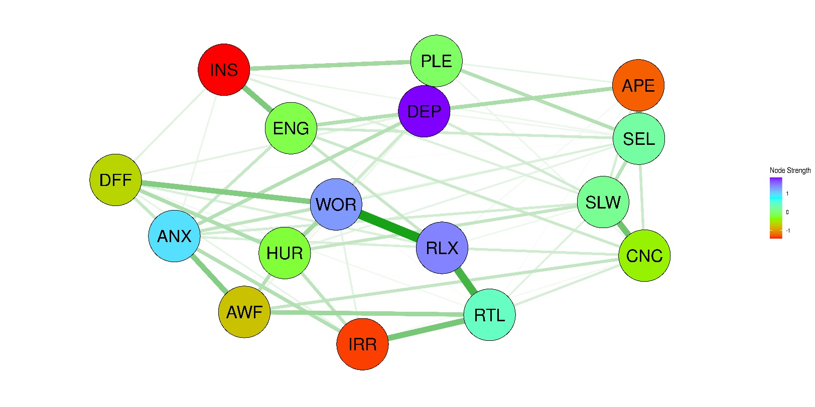
(a)
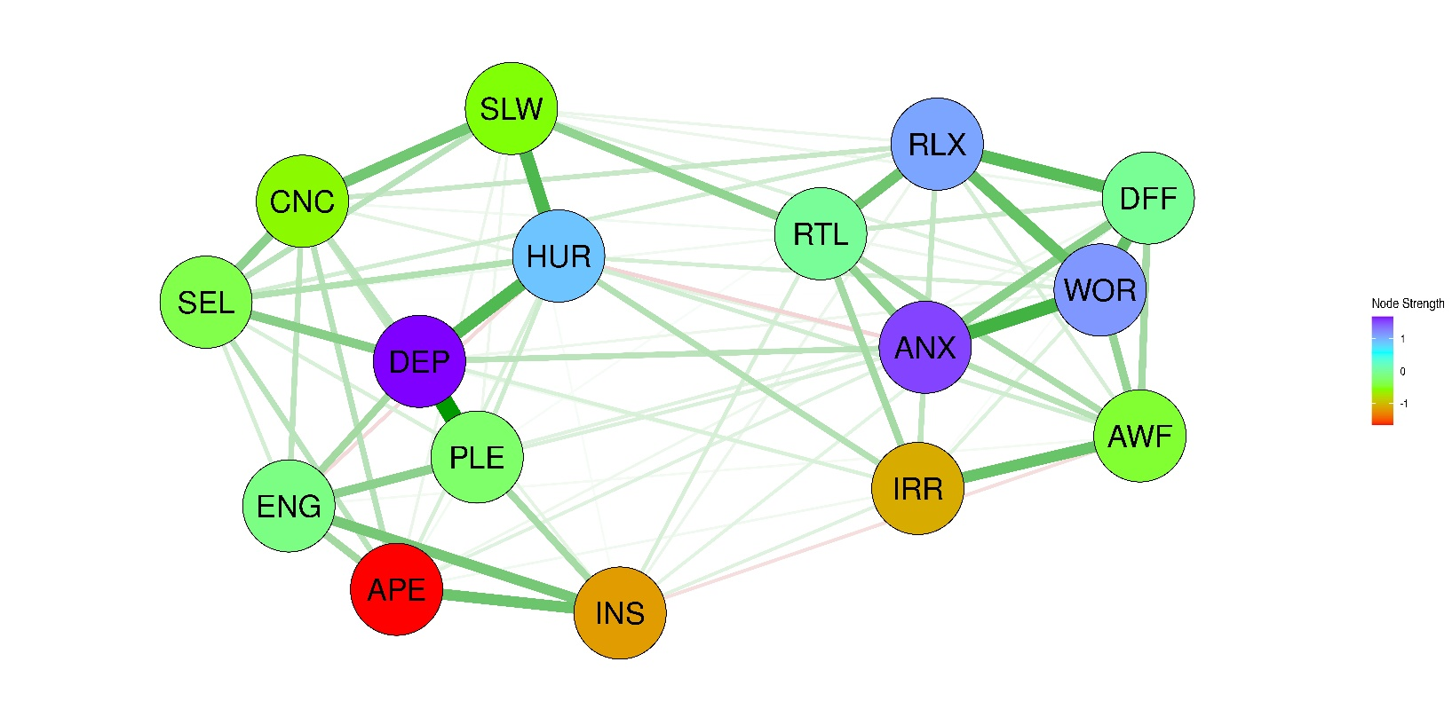
(b)

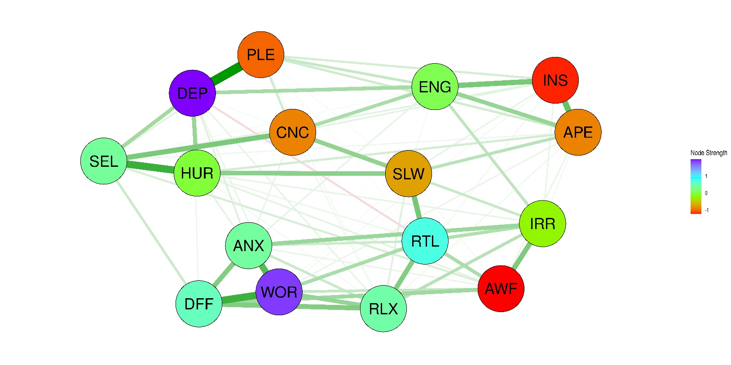
(c)

Figure 1. Network structures of depression and anxiety symptoms in Asian patients with depressive disorders. (a) older (> 65 years), (b) middle-aged (35-64 years), and (c) young adult (18-34 year)
The green lines represent positive associations between the connecting nodes, whereas the red lines represent negative associations. The line thickness reflects the edge strength. The nodes represent depression and anxiety symptoms evaluated using the Patient Health Questionnaire-9 (PHQ-9) and Generalized Anxiety Disorder-7 (GAD-7), respectively.

APE, poor appetite or overeating (PHQ-9); ANX, feeling nervous, anxious, or on edge (GAD-7); AWF, feeling afraid, as if something awful might happen (GAD-7); CNC, trouble concentrating on things, such as reading the newspaper or watching television (PHQ-9); DFF, worrying too much about different things (GAD-7); DEP, feeling down, depressed, or hopeless (PHQ-9); ENG, feeling tired or having little energy (PHQ-9); HUR, thoughts that you would be better off dead or of hurting yourself in some way (PHQ-9); INS, trouble falling or staying asleep, or sleeping too much (PHQ-9); IRR, becoming easily annoyed or irritable (GAD-7); PLE, little interest or pleasure in doing things (PHQ-9); RLX, trouble relaxing (GAD-7); RTL, being so restless that is hard to sit still (GAD-7); SEL, feeling bad about yourself, or that you are a failure or have let yourself or your family down (PHQ-9); SLW, moving or speaking so slowly that other people could have noticed; or the opposite - being so fidgety or restless that you have been moving around much more than usual (PHQ-9); WOR, not being able to stop or control worrying (GAD-7)

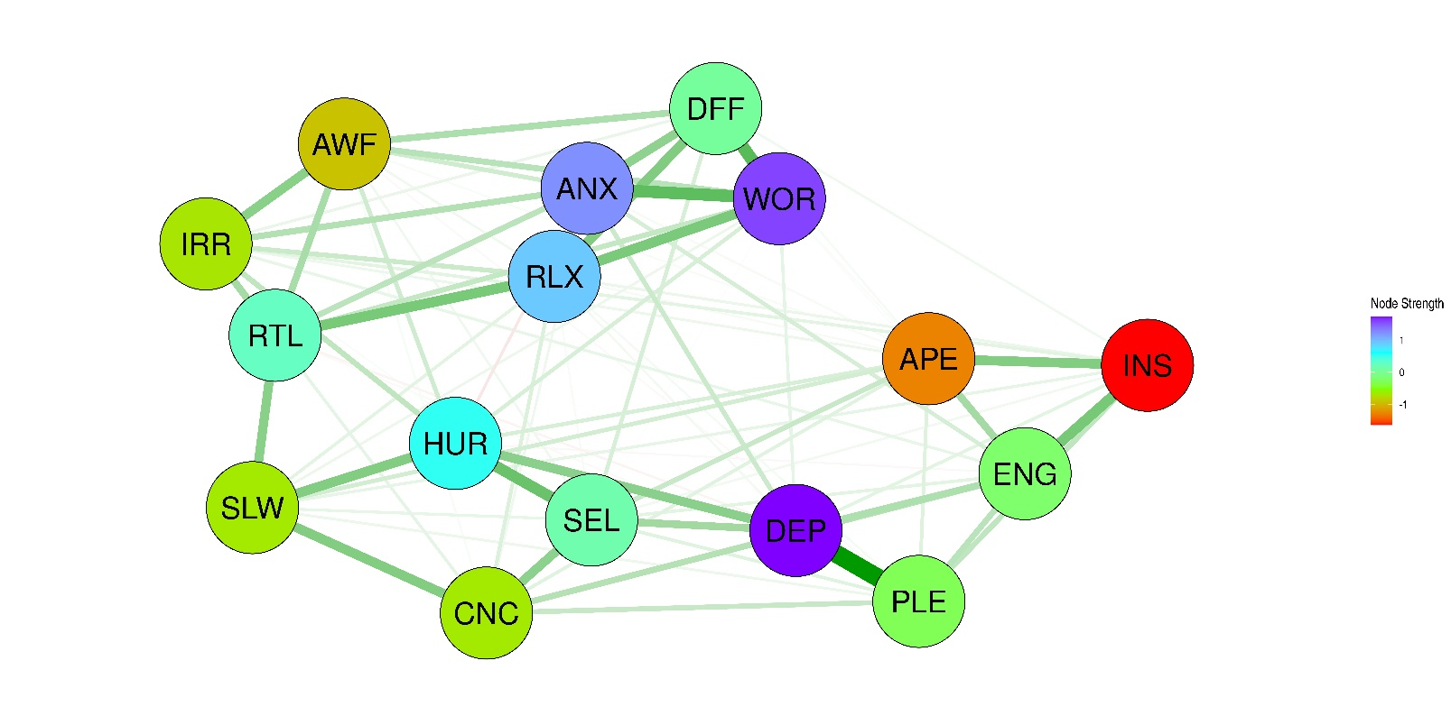
(a)
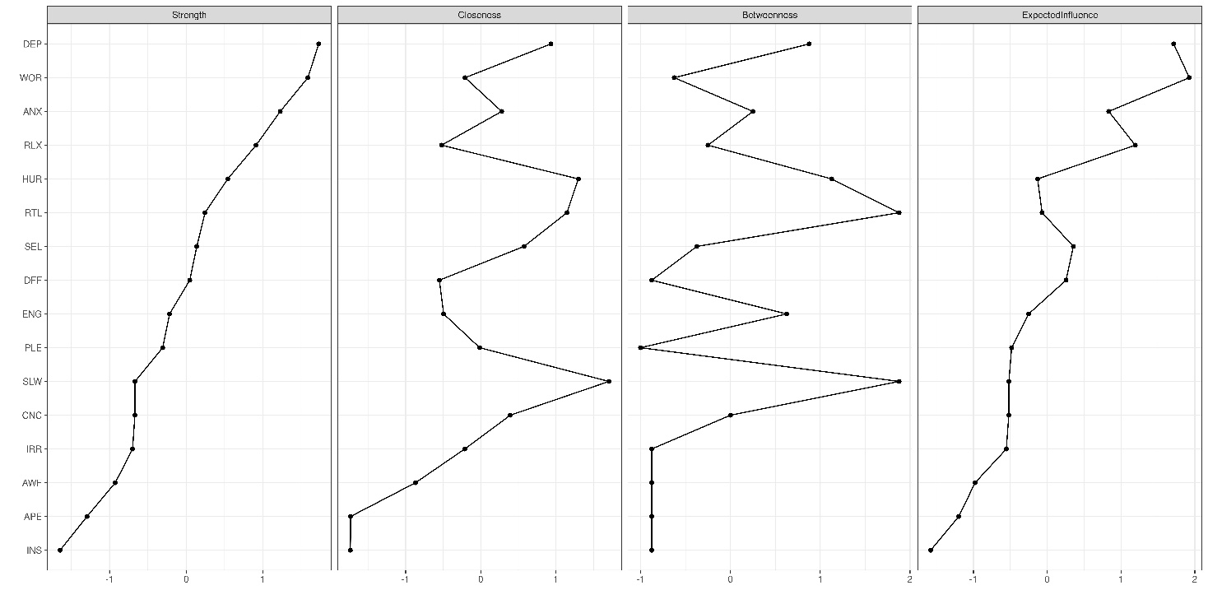
(b)
Figure 2. Network analysis of depression and anxiety symptoms in the cross-sample data set combining the three groups. (a) Network structure of of depression and anxiety symptoms. (b) Node-strength centrality

The green lines represent positive associations between the connecting nodes, whereas the red lines represent negative associations. The line thickness reflects the edge strength. The nodes represent depression and anxiety symptoms evaluated using the Patient Health Questionnaire-9 (PHQ-9) and Generalized Anxiety Disorder-7 (GAD-7), respectively.

APE, poor appetite or overeating (PHQ-9); ANX, feeling nervous, anxious, or on edge (GAD-7); AWF, feeling afraid, as if something awful might happen (GAD-7); CNC, trouble concentrating on things, such as reading the newspaper or watching television (PHQ-9); DFF, worrying too much about different things (GAD-7); DEP, feeling down, depressed, or hopeless (PHQ-9); ENG, feeling tired or having little energy (PHQ-9); HUR, thoughts that you would be better off dead or of hurting yourself in some way (PHQ-9); INS, trouble falling or staying asleep, or sleeping too much (PHQ-9); IRR, becoming easily annoyed or irritable (GAD-7); PLE, little interest or pleasure in doing things (PHQ-9); RLX, trouble relaxing (GAD-7); RTL, being so restless that is hard to sit still (GAD-7); SEL, feeling bad about yourself, or that you are a failure or have let yourself or your family down (PHQ-9); SLW, moving or speaking so slowly that other people could have noticed; or the opposite - being so fidgety or restless that you have been moving around much more than usual (PHQ-9); WOR, not being able to stop or control worrying (GAD-7)

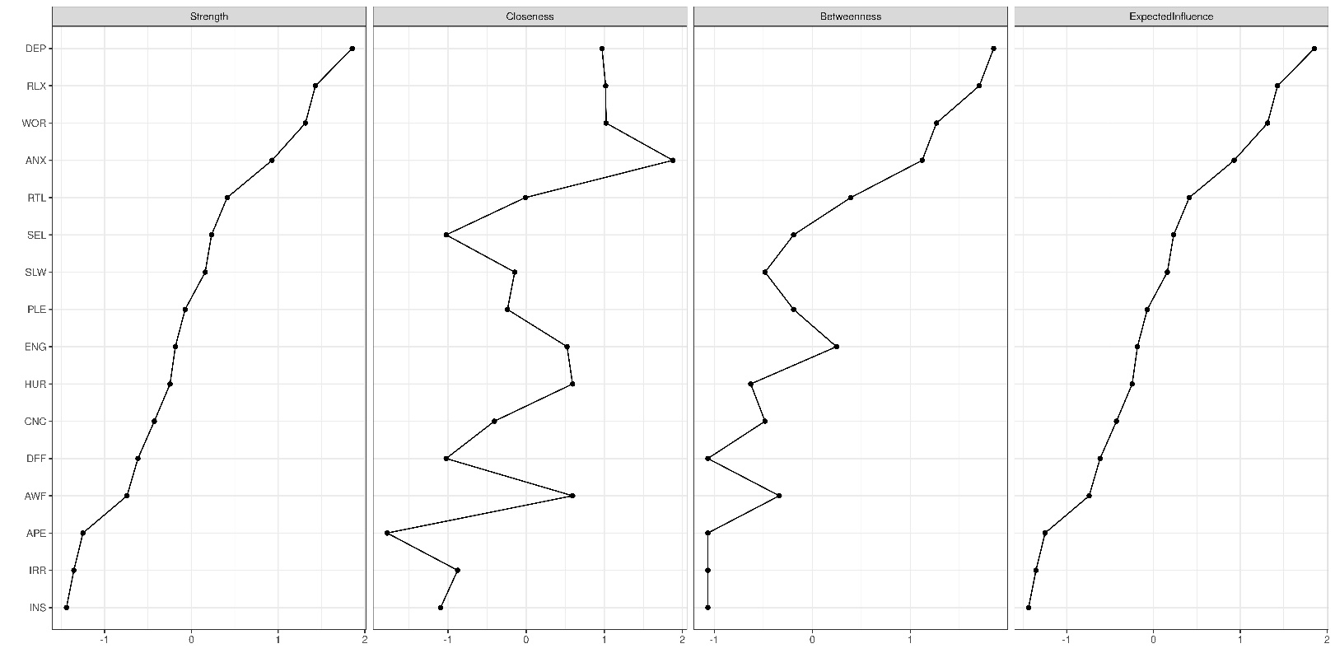
(a)
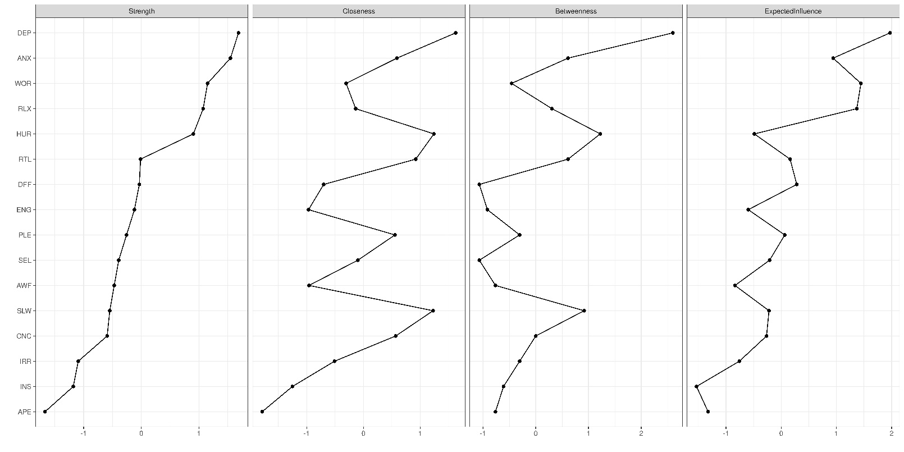
(b)

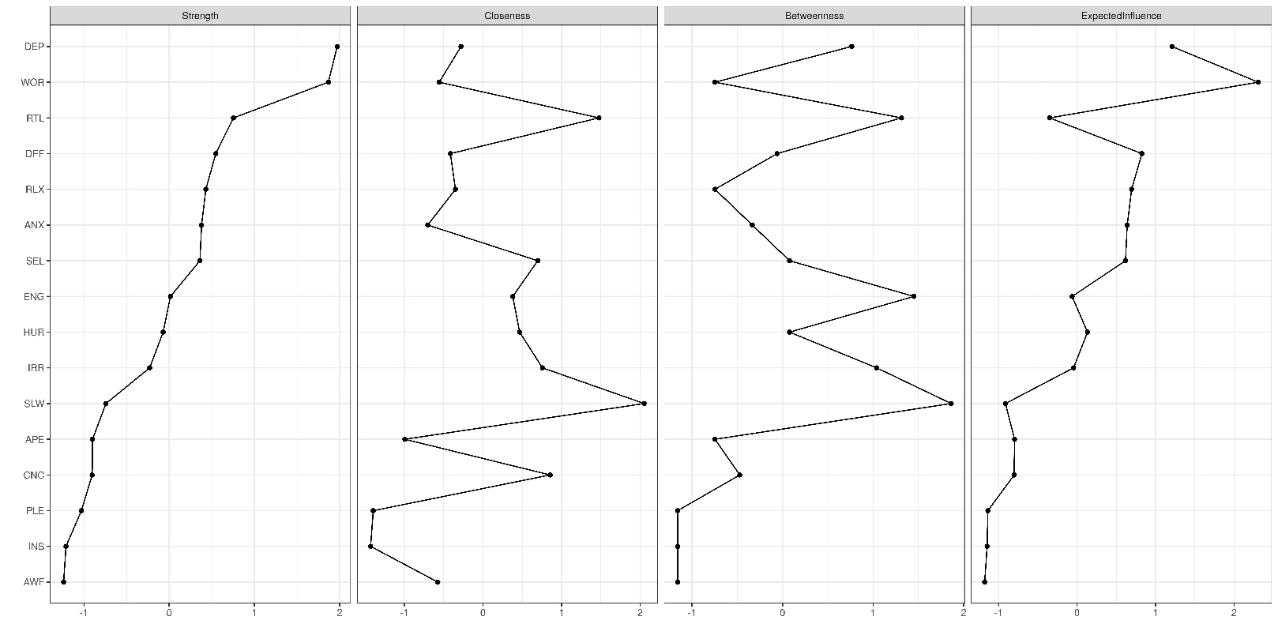
(b)

Supplementary Figure 1. Node strength centralities of depression and anxiety symptoms in Asian patients with depressive disorders. (a) older (> 65 years), (b) middle-aged (35-64 years), and (c) young adult (18-34 year)

APE, poor appetite or overeating (PHQ-9); ANX, feeling nervous, anxious, or on edge (GAD-7); AWF, feeling afraid, as if something awful might happen (GAD-7); CNC, trouble concentrating on things, such as reading the newspaper or watching television (PHQ-9); DFF, worrying too much about different things (GAD-7); DEP, feeling down, depressed, or hopeless (PHQ-9); ENG, feeling tired or having little energy (PHQ-9); HUR, thoughts that you would be better off dead or of hurting yourself in some way (PHQ-9); INS, trouble falling or staying asleep, or sleeping too much (PHQ-9); IRR, becoming easily annoyed or irritable (GAD-7); PLE, little interest or pleasure in doing things (PHQ-9); RLX, trouble relaxing (GAD-7); RTL, being so restless that is hard to sit still (GAD-7); SEL, feeling bad about yourself, or that you are a failure or have let yourself or your family down (PHQ-9); SLW, moving or speaking so slowly that other people could have noticed; or the opposite - being so fidgety or restless that you have been moving around much more than usual (PHQ-9); WOR, not being able to stop or control worrying (GAD-7)

